[ZANG] - [Chuanjie]

Student ID: 699382953

[chuanjiezang@gmail.com](mailto:chuanjiezang@gmail.com)

I choose this restaurant: Desi Rasoi

Website:

https://desirasoi.orderexperience.net/6419a0a3d8c52b083506f7fe/menu

Why are you redesigning the website? What problem do you hope to solve with this website?

The restaurant website has the following problems that need to be solved urgently: 1. The website lists information such as menus and addresses too directly, but lacks tempting food pictures and restaurant photos, which cannot attract customers. 2. The website does not directly list the restaurant's phone number, but uses an external link. For guests using computers, it is impossible to directly obtain the restaurant's phone contact information. I will change this external link to a phone number display method, which takes into account both computer and mobile users. 3. The menu is too cumbersome. As a restaurant selling hamburgers and hot dogs, I don't think it is necessary to attach pictures of each item. It would be better to directly display the product recipe through text. 4. The color and background of the page are too monotonous.

Who is the target audience of your website? Age, gender, interests, etc.

Hamburgers and hot dogs are foods for all ages, so the audience of this restaurant is relatively wide. Therefore, the restaurant needs to stand out from the restaurant culture and website design, showing a specific restaurant atmosphere and culture, so as to attract specific groups and customers. Considering the location and scale of the restaurant, I will highlight young trendy elements in the design to attract young people, because I think the types of food sold by the restaurant are too popular and cannot attract older local customers to choose this restaurant, while young customers are more concerned about personalized choices.

What type of content will your website contain? Including text, images, videos, etc.

My redesigned website will contain text, images. Given the nature of this restaurant, it may not contain videos.

Step1:  
F12 and copy html elements from the website

Step2:

Delete JavaScript and <script> tag, keep html and css styles.

Step3:

Then, finish the coding part to build pages for the chosen restaurant.

Before next steps, make sure set up XAMPP etc.

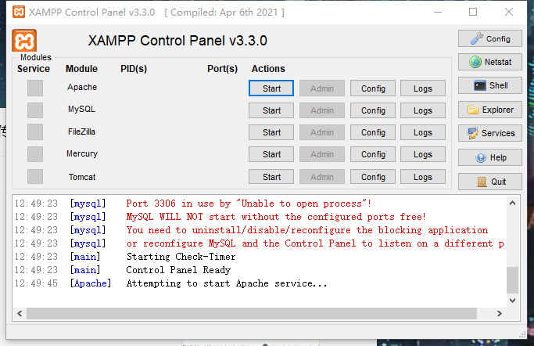

Step4:

Create a new data on Mysql

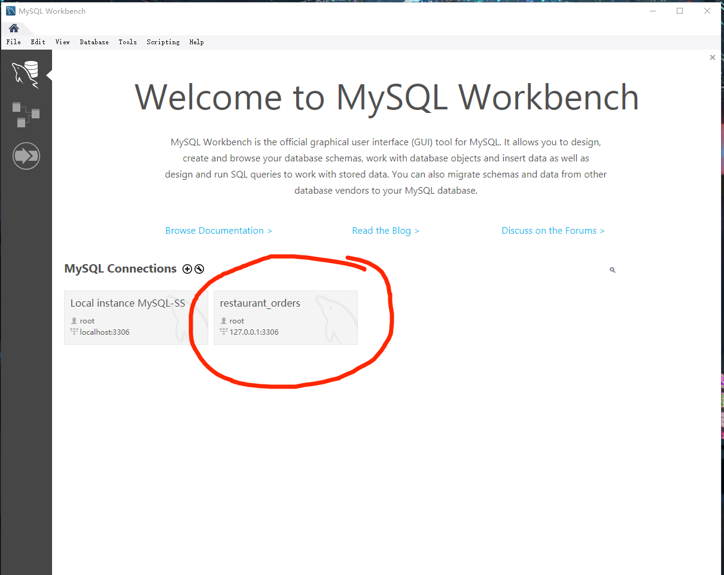

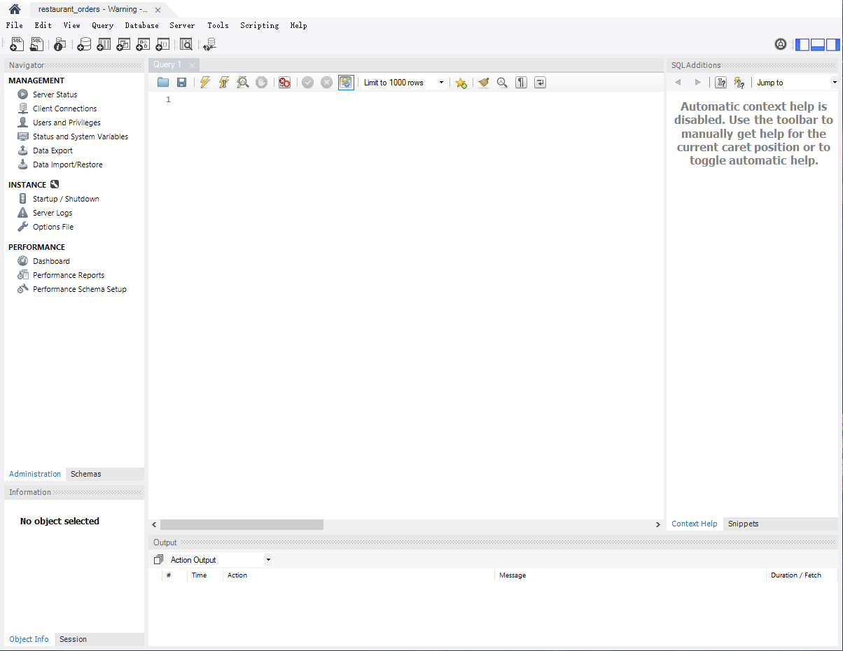

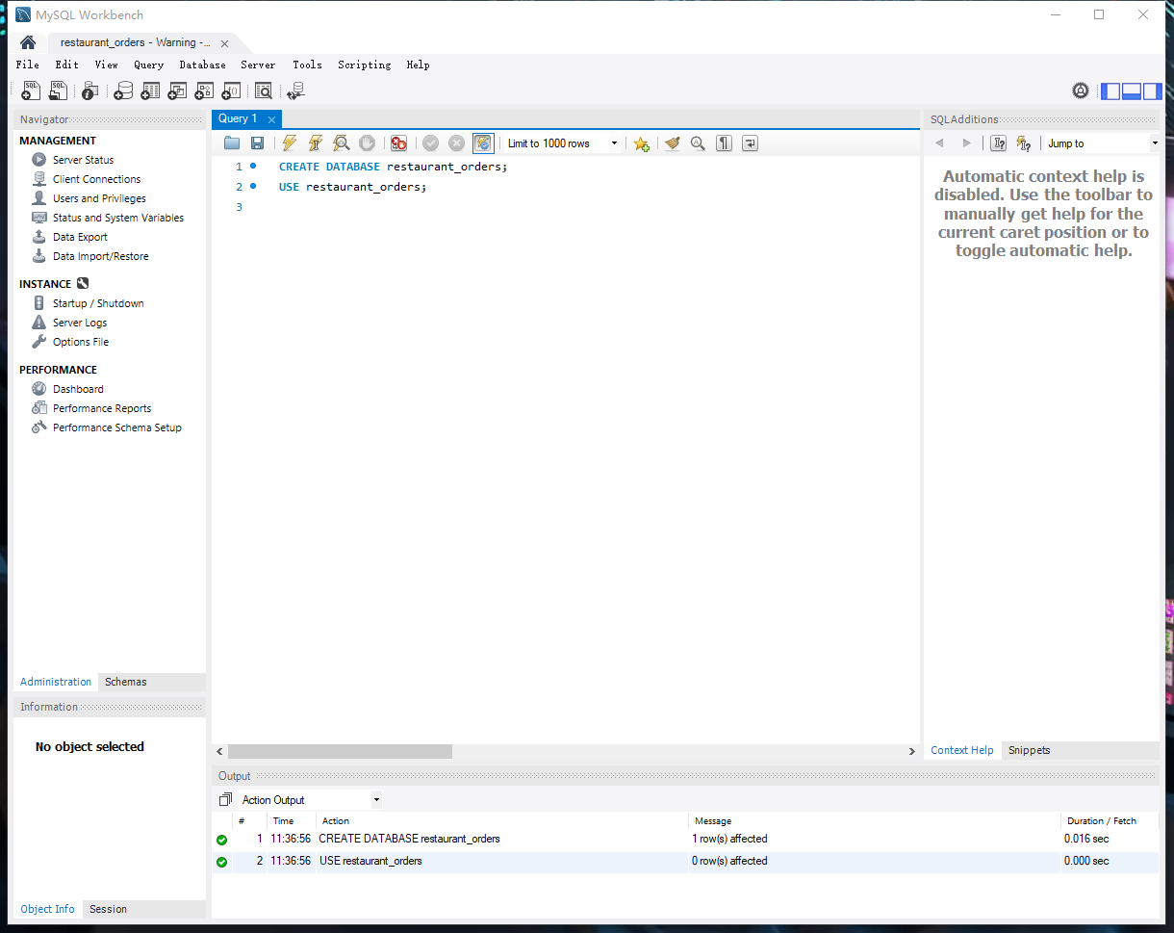

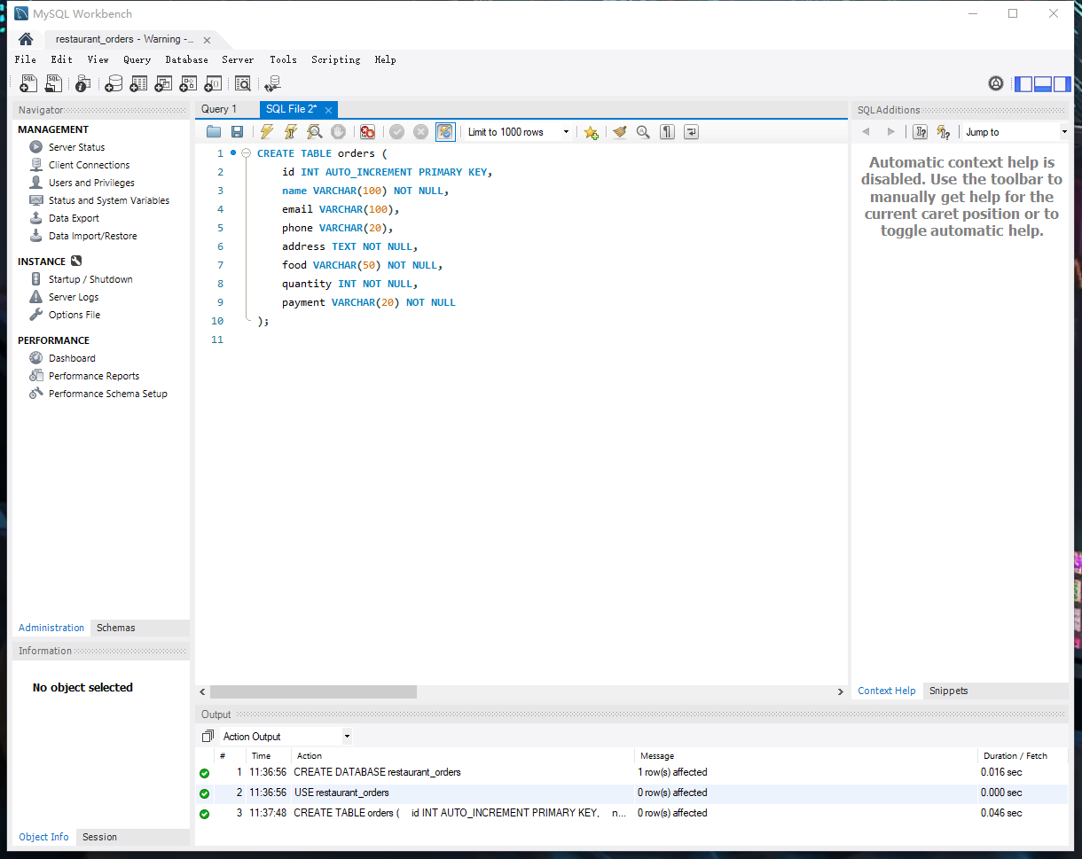

Step5:

Update PHP code to connect to MySQL

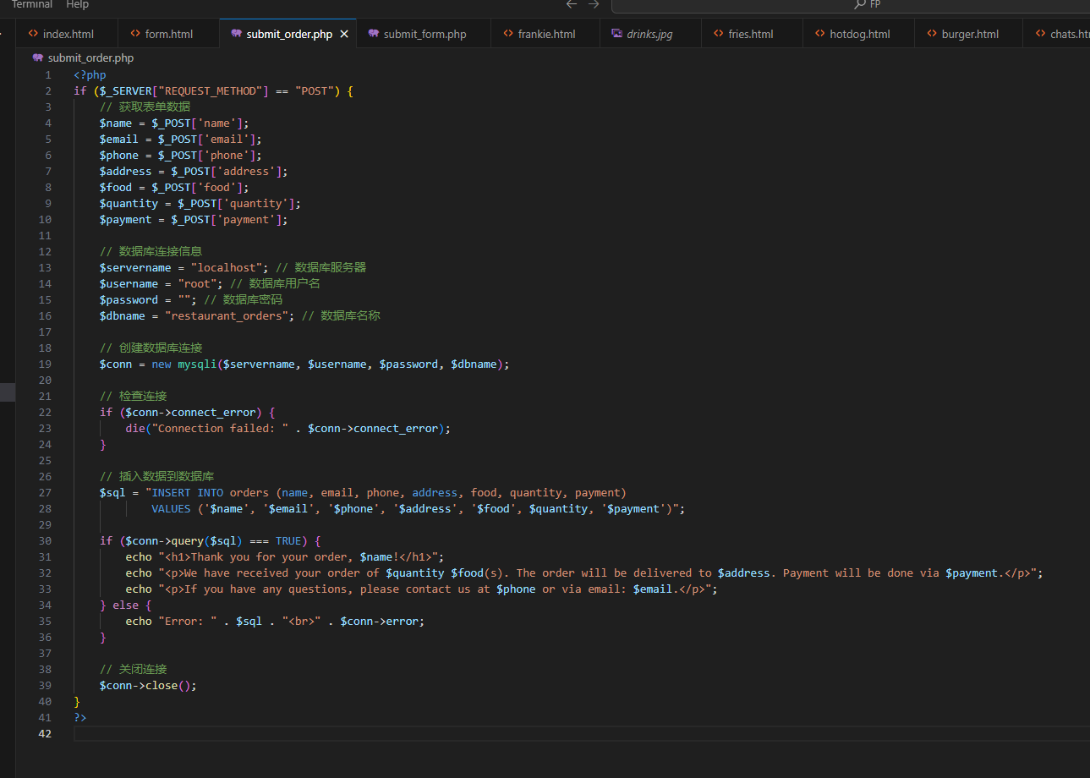

Step6: Test database connection and insert data

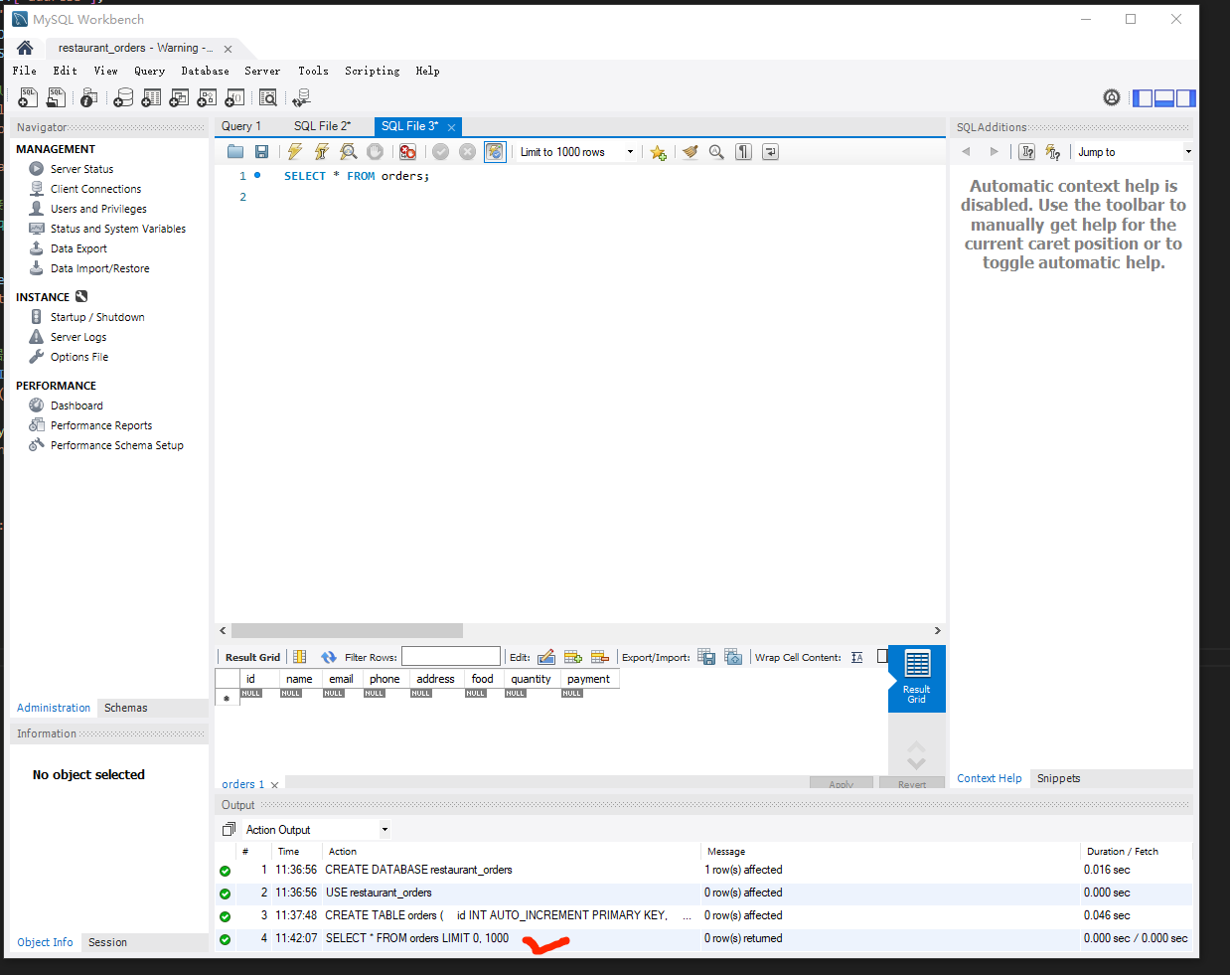

Step7: Create a new page orders_history.html, which will display all orders submitted in the database.

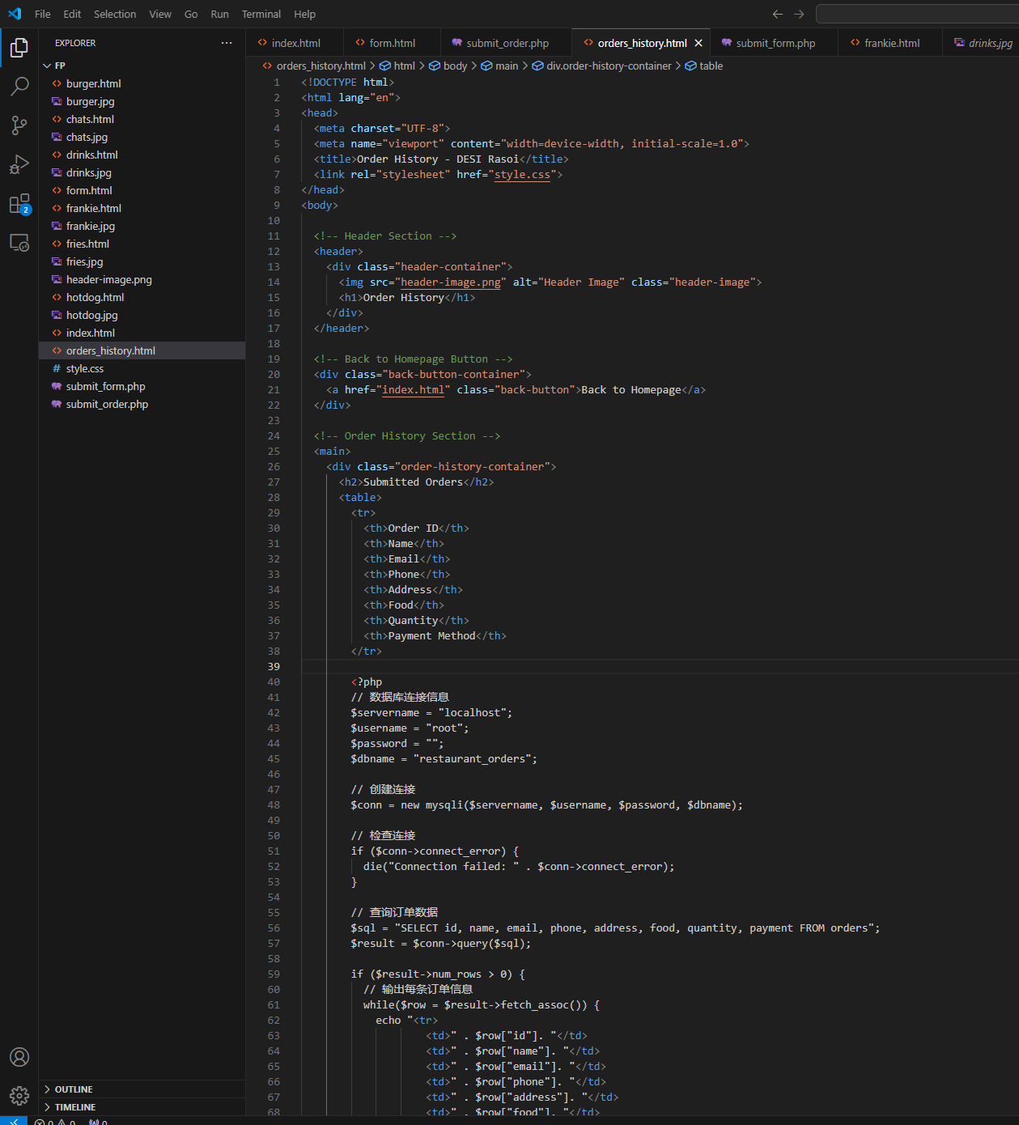

Step8:

order_details.php

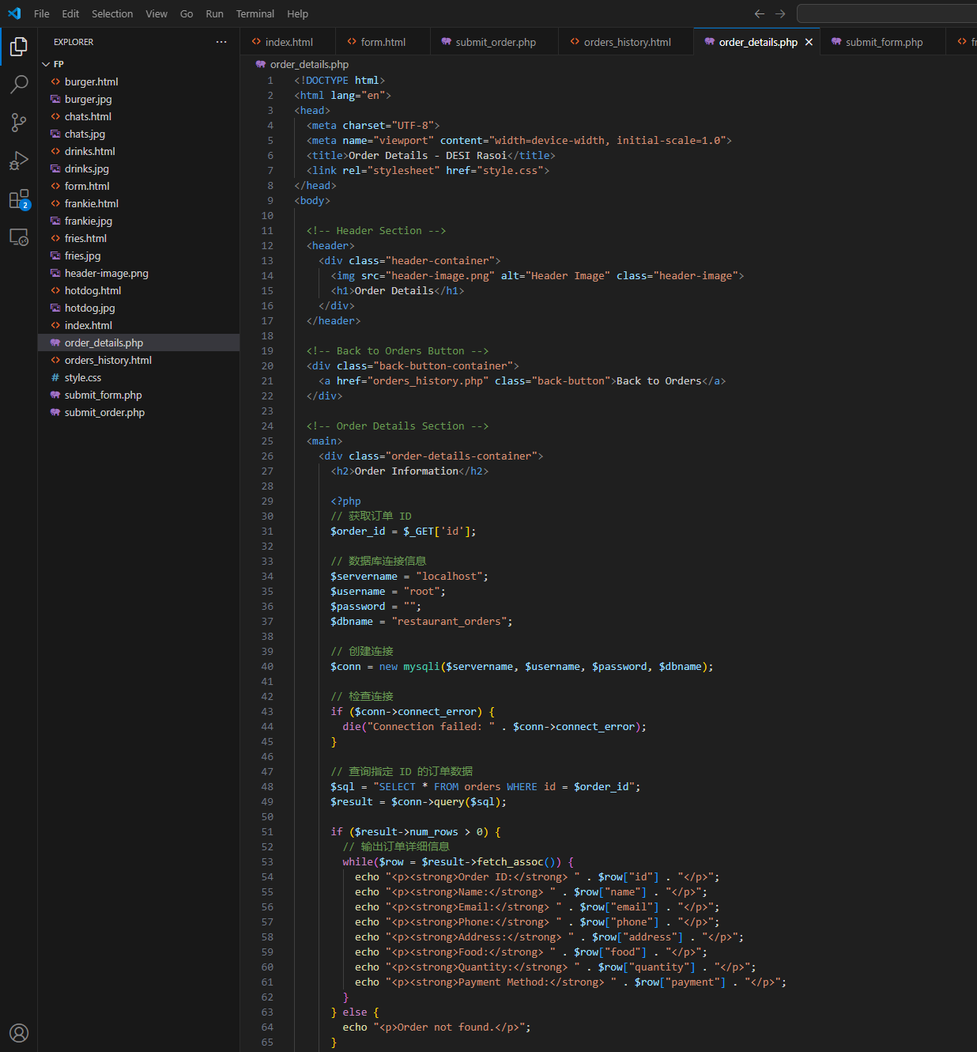

Step9: Enhance input validation and error handling of order system

Add JavaScript validation in form.html

